**Extrinsic semiconductors**

Let's understand the second type of semiconductors which are extrinsic semiconductors.

How are they different from the intrinsic semiconductors?

While intrinsic are the pure form of semiconductors, impurities need to be added to the intrinsic to improve their conductivity, and these semiconductors with impurities are called as extrinsic semiconductors.

Extrinsic semiconductors are further subdivided into p-type or trivalent and n-type of pentavalent.

As we can see, we have three electrons orbiting in the outermost shell of the atom that is called as trivalent and in the other atom we have five electrons orbiting, hence it is called pentavalent.

The common examples of trivalent are boron, gallium and indium, and that of pentavalent are phosphorus, arsenic andantimony.

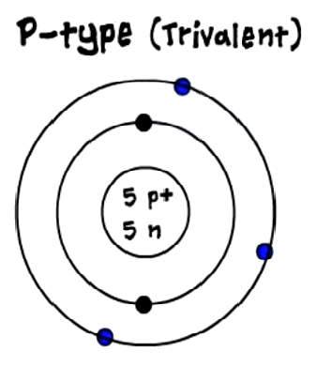The process of adding these impurities to the intrinsic semiconductors is called as doping and the impurities that improve the conductivity of the semiconductors are called as dopers.

**p-type**

In case of trivalent three electrons of boron will form three bonds with silicon and at the forth bond of silicon there will be one empty space, or hole, and as seen previously the immediate neighboring electron will be attracted towards the hole that's creating another empty space in its previous location.

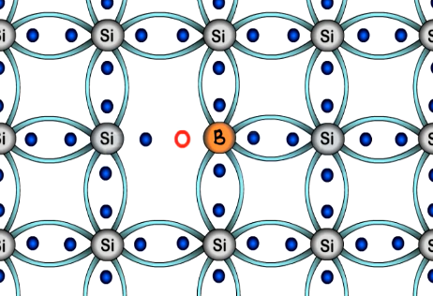Simultaneously the electrons of the silicon atoms at the internal energy and keep breaking the covalent bonds at room temperature that's creating further free electrons and this movement will go on in the same manner. Therefore the number of holes generated in this structure dominate over the electrons, hence this structure is called as a p-type semiconductor.

**n-type**

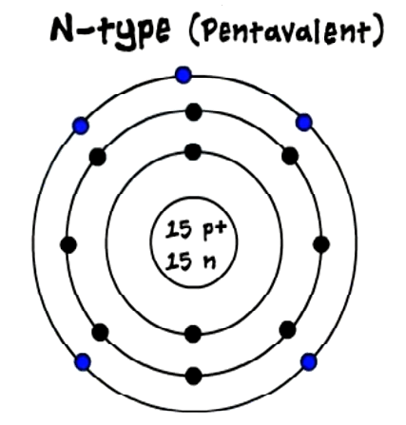Now let's look at the second type of extrinsic semiconductor, the n-type or pentavalent semiconductor.

In this the atomic structure of the n-type r pentavalent semiconductor will have five electrons in the outermost shell.

As silicon requires only four additional electrons to attain stability, in pentavalent atom we have one extra electron as a valence electron, so we get a net negative charge due to this extra electron hence its name is n-type semiconductor.

Common examples of n-type or pentavalent impurities are phosphorus, arsenic and antimony.

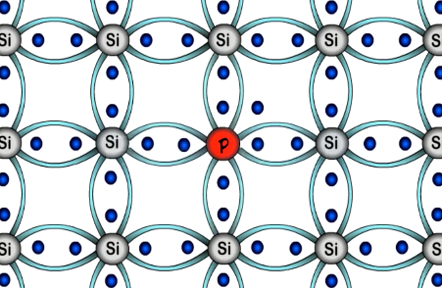When we add pentavalent impurities to an intrinsic semiconductor, we observe that the phosphorus atom forms four bonds with four silicon atoms, fulfilling the needs of silicon, but even after that remains one electron which does not form any bond and remains free and, unlike the previous structures, here we get free electron readily available for conduction. This electron rotates randomly around the phosphorus atom fallowing a circular motion. In addition to this, the breaking of bonds as seen in the intrinsic semiconductors happens here as well.